**Using Primary Key Class @Id**

In this method, we create a separate class representing the business key. We annotate this class with @*Embeddable,* marking it a composite-id class.

In the following example, the CoursePK consist of two variables, *tutor* and *title*. The combination of these two attributes makes a composite key for *Course class.*

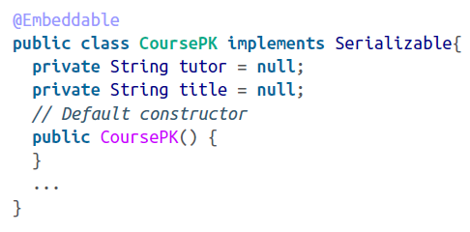

Notice that the class has been decorated with the @*Embeddable* annotation.

Make sure the class implements the java.io.Serializable interface with a default constructor. Also, it must have the hashCode and equals method implemented; they will help Hibernate distinguish uniqueness.

The next step is to embed this class on our persistent class’s id variable. We do this by using our simple @Id annotation:

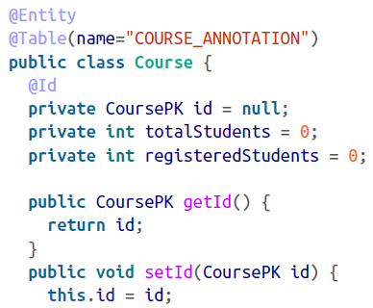

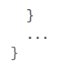

The Course persistent POJO has three variable: id, totalStudents, and registeredStudents. As we know, the id is a CoursePK type – a composite class with two variables, *tutor* and *title* – making up the primary class for our *Course* object.

Run a test case and see how the composite key has been formed on the table:

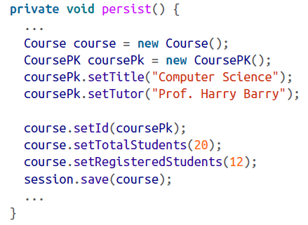

Execute the SELECT statement on the table to check the result, as shown:

